Introduction to Differential Equations

Assignment # 12

Tian Xiaoyang

26001904581

P1.

(a)

(b)

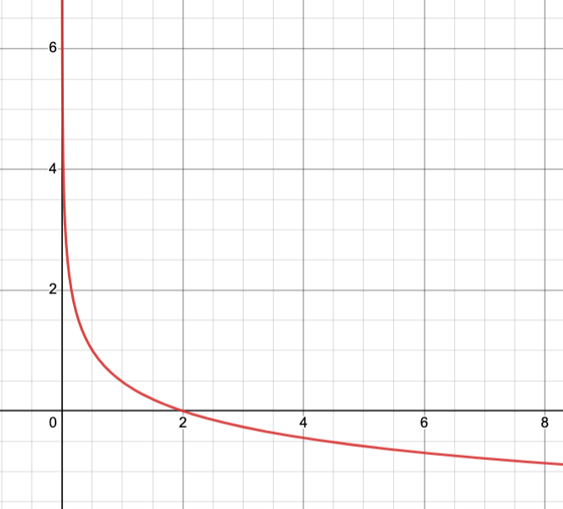

P2.

(a)

(b)

P3.

(b)

P4.

P5.